

**Project Report**

**on**

**TRAVEL AND TOURISM**

Submitted to

**LOVELY PROFESSIONAL UNIVERSITY**

in partial fulfilment of the requirements for the award of degree of

**Bachelor of Computer Science and Engineering**

**Submitted By Submitted to**

**Sushmita Kumari Ms Navneet Kaur**

**[11809704] [Faculty]**

**LOVELY FACULTY OF TECHNOLOGY & SCIENCES**

**LOVELY PROFESSIONAL UNIVERSITY**

**PUNJAB**

**9th October , 2020**

**ACKNOWLEDGMENT**

I would like to express my deepest appreciation to all those who provided me the possibility to complete this report.  A special gratitude I give to our faculty **Ms Navneet Kaur** , whose contribution in stimulating suggestions and encouragement,  helped me to coordinate my project especially in writing this report.

Furthermore , I appreciate the guidance given by other supervisor as well as the panels especially in our project presentation that has improved our presentation skills thanks to their comment and advices.

**Thanking You**

**Sushmita Kumari**

**Table of Contents**

I Title Page i

II Acknowledgement ii

III Table of Contents iii

**Chapter Particulars Page No.**

1. Introduction…………………………………………………………….1
2. Technology used……………………………………………………….2
3. Modules………………………………………………………...............4
4. Screen Shots with coding [Including figure numbers]…………………6
5. Validation Checks……………………………………………………...69
6. Implementation and Maintenance……………………………………...70
7. Testing (Testing techniques and Testing strategies)……………………71
8. Future scope of the project……………………………………………..72
9. GitHub link and video presentation link……………………….............73

References…………………………………………………………………………..74

**CHAPTER 1**

**INTRODUCTION**

* 1. **Welcome to Incredible India –**

**“Bharat@yatara.com - Travel to India”** is a online tour travelling agent which provide memorable experience to the customer’s by introducing tour packages .

Here, we full fill the needs of those people who are planning a trip to historical places, adventures, and pilgrims in India. As we all knew that India is an incredible country and every single place has its specialty in it. And, due to which it attracts lots of tourists. But, the benefit of choosing our site is you will find a package at a reasonable rate with some discount, historical magazine containing story which becomes a reason for the popularity of that area and entertainment.

**CHAPTER 2**

**TECHNOLOGY USED**

* 1. **Technology used**

We have used different type language to form frontend of the website. The following are mentioned below.

* + 1. **HTML**

Stands for "Hypertext Markup Language." HTML is the language used to create [**webpages**](https://techterms.com/definition/webpage). "Hypertext" refers to the **hyperlinks** that an HTML page may contain. "Markup language" refers to the way **tags** are used to define the page layout and elements within the page.

* + 1. **CSS**

CSS stands for “**Cascading Style Sheets”**. It describes how HTML elements are to be displayed on screen, paper, or in other media . CSS saves a lot of work. It can control the layout of multiple web pages all at once. It can style html through following ways:

* + - 1. External style
      2. Inline style
      3. Internal style
    1. **JavaScript**

JavaScript is a “**programming language”** commonly used in “ [**web development**](https://techterms.com/definition/web_development)”. It was originally developed by Netscape as a means to add dynamic and interactive elements to websites. While JavaScript is influenced by Java, the syntax is more similar to [C](https://techterms.com/definition/cplusplus) and is based on ECMAScript, a scripting language developed by Sun Microsystems.

* + 1. **jQuery**

jQuery is a “[**JavaScript**](https://techterms.com/definition/javascript) **library”** that allows web developers to add extra functionality to their websites. It is [open source](https://techterms.com/definition/opensource) and provided for free under the MIT license. In recent years, jQuery has become the most popular JavaScript library used in [web development](https://techterms.com/definition/web_development).

**CHAPTER 3**

**MODULES**

* 1. **Modules**

We have used several modules in form of navbar in our website to give more options to the customers and to have clear view of our objective. The modules are following defined below-

* + 1. **Login/ Signup**
    2. **Home page**

It contains all necessary information which required for new customer’s to know before they choose any tour packages. Some, of the modules are also been included in it which are mentioned below:

* + - 1. Objectives and guidelines
      2. Offers
      3. About us
      4. Contact us
      5. Share us
    1. **Custom packages**

In this module we have mentioned types of tour packages . We will provide to the customer . So, it is divided into further three modules which are mentioned below.

* + - 1. Adventure - This module contain further two modules which are mentioned below :
         1. Manali
         2. Goa Beach
      2. Pilgrims - This module also contain further two modules which are mentioned below:
         1. Kedar Dham
         2. Buddha
      3. Heritage - Similarly, this module also contain further two modules which are mentioned below:
         1. Rajasthan
         2. Jabalpur
    1. **About us**
    2. **Contact us**
    3. **Feedback**

This module contains feedback form to know the reviews of customers while visiting our site or giving review after having any tour under our services. It also used to resolve query of the costumer’s.

**CHAPTER 4**

**SCREEN SHOTS WITH CODING**

* 1. **Screen Shots with coding**

In this chapter, we will describe every page of website design in detail with help of code using html , css and javascript.

* + 1. **Login / Signup page-**

It is divided into cover and form section here. 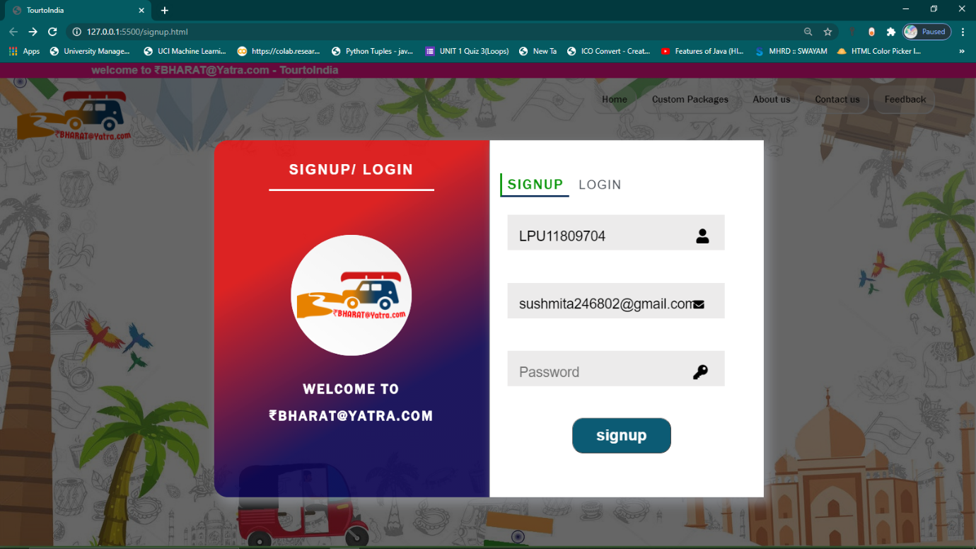

* **HTML Code:**

 <section id="body">

<section id ="background"> //background

    <marquee class="ad" style = "border:2px deeppink solid ;background-color:deeppink; color:ghostwhite;" behavior ="alternate"><b>welcome to ₹BHARAT@Yatra.com - TourtoIndia</b></marquee>

    <nav id="background2">  <img src="main/logo1.png"/>

        <div id = "container">

            <ul>

                <a href="#background"><li>Home</li></a>

                <li>Custom Packages

                    <ul>

                        <li>Adventure

                        <ul>

                            <a href="manali/Manali.html"><li>Manali</li></a>

                            <li>Goa beach</li>

                        </ul>

                        </li>

                        <li> Piligrams

                            <ul>

                                <li>KedarDham</li>

                                <li>Buddha</li>

                            </ul>

                        <li>Heritage

                            <ul>

                                <li>Rajasthan</li>

                                <li>Jabalpur</li>

                            </ul>

                        </li>

                    </ul>

                </li>

                <a href="#aboutus"><li>About us</li></a>

                <a href="#contactus"><li>Contact us</li></a>

               <a href="Main/feedback.html"><li >Feedback</li></a>

            </ul>

        </div>

    </nav>

        <div id="loginScreen"> //login screen

        <div id ="wrapper" >

            <div class="left">

                <h3>Signup/ Login</h3>

              <img src="/Main/logo1.png" >

              <h1>Welcome To</h1>

              <h2>₹BHARAT@Yatra.com</h2>

            </div>

            <div class="right">

              <div class="tabs">

                <ul>

                  <li class="signup_li">signup</li>

                  <li class="login_li">login</li>

                </ul>

              </div>

              <div class="signup">

                <form id="form" onsubmit="return validate()"> //signup form

                <div class="input_field">

                  <input  type="text" placeholder="Username" id="username" class="input">

                  <i class="fa fa-user fa-lg"></i>

                </div>

                <div class="input_field">

                  <input type="text" placeholder="E-mail" id="email" class="input"><i class="fa fa-envelope"></i>

                </div>

                <div class="input_field">

                  <input type="password" placeholder="Password" id="password" class="input"><i class="fa fa-key fa-lg"></i>

                </div>

                <button class="btn">signup</button>

              </a>

            </form>

            </div>

              <div class="login">

                <form id="form1" onsubmit="return validate1()"> // login form

                <div class="input_field">

                  <input type="text" placeholder="E-mail" id="email1" class="input"><i class="fa fa-envelope"></i>

                </div>

                <div class="input_field">

                  <input type="password" placeholder="Password" id="password1" class="input"><i class="fa fa-key fa-lg"></i>

                </div>

                <a href="/main.html">

                  <button  class="btn"> Login</button>

              </a>

            </form>

            </div>

          </div>

        </div>

        </div>

    </section>

</section>

* **CSS Code:**

**/* BACKGROUND */**

*{

  margin: 0;

  padding: 0;

  box-sizing: border-box;

  outline: none;

  text-decoration: none;

  list-style: none;

  font-family: 'Nunito', sans-serif;

}

body{

  background:#fff;

}

#wrapper{

  display: flex;

  max-width: 940px;

  width: 100%;

  height: 650px;

  position: relative;

  margin-top: -4rem;

  z-index: 50;

  margin-left: 19rem;

  /* top: 50%; */

  /* left:75%; */

  /* align-items: center; */

  /* transform: translate(-50%,-50%); */

}

#cover{ //darkening page

  position:fixed;

  background:rgba(0,0,0,0.6);

  z-index:5;

  width:100%;

  height:100%;

  top: 0;

  left: 0;

    }

#wrapper .left,#wrapper .right{

  height: 100%;

  padding: 40px;

  padding-left: 90px;

  padding-right: 100px;

  margin: 10px;

}

//Wrapping left side of form

#wrapper .left{

  background: linear-gradient(-30deg,rgba(15, 7, 93, 0.822) 30%,rgba(248, 19, 19, 0.808)70%);

  border-radius: 25px 0px 0px 25px;

  padding: 40px;

  padding-left: 100px;

  padding-right: 100px;

  align-items: center;

  box-shadow:8px 10px 18px 3px rgba(139, 141, 148, 0.829) ;

}

#wrapper .left h3{

  text-align: center;

  text-transform: uppercase;

  letter-spacing: 3px;

  color: #fff;

  font-size: 25px;

  padding-bottom: 20px;

  border-bottom: 4px solid white;

  margin-bottom: 6rem;

}

#wrapper .left h2, #wrapper .left h1{

    text-align: center;

    text-transform: uppercase;

    letter-spacing: 3px;

    color: #fff;

    font-size: 25px;

    padding-bottom: 20px;

  font-family: 'Franklin Gothic Medium', 'Arial Narrow', Arial, sans-serif;

}

#wrapper .left img{

  width: 220px;

  margin: 1.25rem ;

  margin-top: -2rem;

  margin-left:2rem ;

  margin-bottom: 2rem;

  border-radius: 110px 110px 110px 110px;

  background:linear-gradient(35deg,rgb(255, 255, 255) 0%,rgb(241, 241, 241)100%),white;

  border:  initial;

}

//Wrapping right side of form

#wrapper .right{

  background: #fff;

  box-shadow:8px 10px 18px 3px rgba(139, 141, 148, 0.829) ;

margin-right: -4rem;

margin-left: -0.42rem;

}

#wrapper .right .tabs ul{

  text-align: center;

  margin-top: 1rem;

  margin-left: -11rem;

  margin-bottom: 1.5rem;

  font-size: 27px;

}

#wrapper .right .tabs ul li{

  display: inline-block;

  margin:0px;

  padding: 5px 10px;

  font-size: 22px;

  color: #494f57;

  text-transform: uppercase;

  letter-spacing: 2px;

  cursor: pointer;

}

#wrapper .right .tabs ul li.active{

  border-bottom: 4px solid #0a2c58;

  border-left: 4px solid #089508;

  font-size: 27px;

  font-family: 'Franklin Gothic Medium', 'Arial Narrow', Arial, sans-serif;

  color: #089508;

}

#wrapper .right .signup,

#wrapper .right .login{

  margin-top: 20px;

}

#wrapper .right .input_field{

  margin-bottom: 15px;

}

#wrapper .right .input_field .input{

  width: 400px;

  /* ?padding: 10px 5px; */

  border: 3px solid white;

  font-size: 25px;

  margin-right:-3rem ;

  margin-left: -3rem;

  background: #ecebeb;

   padding: 10px;

   padding-left: 1rem;

   padding-right: 2rem;

  padding-top: 1.2rem;

  margin-bottom: 2rem;

  color: black;

}

#wrapper .right .input_field .input:hover {

    border:3px solid rgba(20, 50, 133, 0.466);

     background-color: rgba(53, 139, 46, 0.486);

}

input:focus, textarea:focus

  {

    box-shadow: 0 0 4px #24b924;

    outline-offset: 0px;

    outline: none;

  }

#wrapper .right button{

    background-color : #0c5b74;

    border-radius: 20px;

    color : rgb(255, 255, 255);

    width: 9rem;

    padding: 0.7rem;

    text-decoration: none;

    align-items: center;

    margin-left: 3rem;

text-align: center;

    font-size: 28px;

    font-weight : bold;

}

#wrapper .right .btn:hover{

  background-color: blue;

}

button:focus{

   border: 3px solid rgb(70, 9, 99);

}

input_field i{

}

* **Javascript Code:**

**//Sign Up**

function validate()

{

let uName = document.getElementById('username').value;

let eMail = document.getElementById('email').value;

let passWord = document.getElementById('password').value;

if(uName==="" || eMail==="" || passWord==="")

{

alert('Please fill all the fields');

return false;

}

const emailRegex = /^([A-Za-z0-9_\-\.])+\@([A-Za-z0-9_\-\.])+\.([A-Za-z]{2,4})$/;

if (!emailRegex.test(eMail)) {

alert('Email is not correct');

return false;

}

if(passWord.match(/[a-z]/g) && passWord.match(/[A-Z]/g) && passWord.match(/[0-9]/g) && passWord.match(/[^a-zA-Z\d]/g) && passWord.length >= 8)

{alert('You have signed up successfully');

setTimeout(function() {window.location = "main.html" }); // Linked to main .html

}

else

{

if(passWord.length<8)

{

alert('Password length must be minimum of 8 characters');

return false;

}

else

{

alert('Password format is not correct');

return false;

}

}

}

//Login

function validate1()

{

    let eMail = document.getElementById('email1').value;

    let passWord = document.getElementById('password1').value;

    if(eMail==="" || passWord==="")

    {

        alert('Please fill all the fields');

        return false;

    }

    const emailRegex = /^([A-Za-z0-9_\-\.])+\@([A-Za-z0-9_\-\.])+\.([A-Za-z]{2,4})$/;

    if (!emailRegex.test(eMail)) {

        alert('Email is not correct');

        return false;

    }

    if(passWord.match(/[a-z]/g) && passWord.match(/[A-Z]/g) && passWord.match(/[0-9]/g) && passWord.match(/[^a-zA-Z\d]/g) && passWord.length >= 8)

    {

        alert('You have signed up successfully');

        setTimeout(function() {window.location = "main2.html" }); // Linked to main .html

    else

    {

        if(passWord.length<8)

        {

            alert('Password length must be minimum of 8 characters');

            return false;

        }

        else

        {

            alert('Password format is not correct');

            return false;

        }

    }

}

* **JQuery Code:**

  <script>

        $(document).ready(function(){

  $(".login").hide();

$(".signup_li").addClass("active");

$(".login_li").click(function(){

  $(this).addClass("active");

  $(".signup_li").removeClass("active");

  $(".login").show();

   $(".signup").hide();

});

$(".signup_li").click(function(){

  $(this).addClass("active");

  $(".login_li").removeClass("active");

  $(".signup").show();

   $(".login").hide();

});

});

* + 1. **Home page-**

It is divided into different sections mentioned in below:

* + - 1. **Background :**

**Fig 4.1.2.1.1- Main background of the page** 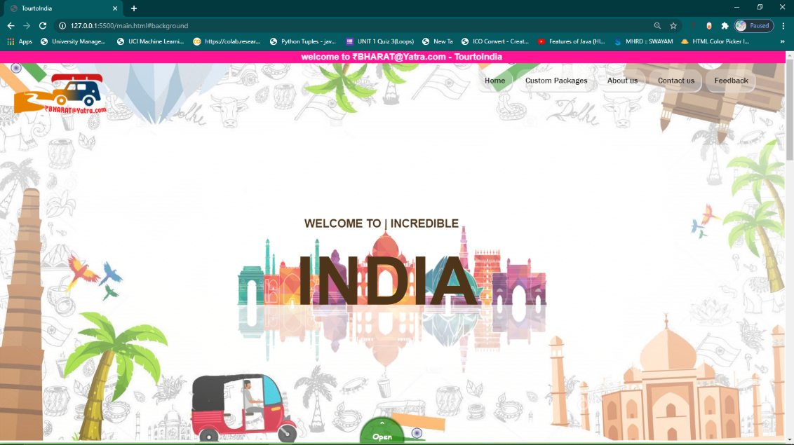

Here, navbar position is fixed and open button is used to scroll down.

**Html Code:**

<nav id="background2"> //id 🡪 navebar (as container),logo,heading andopen btn

<img src="main/logo1.png"/> //image of logo

   <div id = "container"> // list of navbar button

      <ul>

      <a href="#background"><li>Home</li></a> //link to same page #background

           <li>Custom Packages

               <ul>

                  <li>Adventure

                     <ul>

<a href="manali/Manali.html"><li>Manali</li></a> //link to another page

                            <li>Goa beach</li>

                      </ul>

                   </li>

                    <li> Piligrams

                        <ul>

                           <li>KedarDham</li>

                           <li>Buddha</li>

                        </ul>

                      <li>Heritage

                            <ul>

                               <li>Rajasthan</li>

                               <li>Jabalpur</li>

                             </ul>

                       </li>

                  </ul>

             </li>

    <a href="#aboutus"><li>About us</li></a> //link to same page #aboutus

   <a href="#contactus"><li>Contact us</li></a>//link to same page #contactus

   <a href="Main/feedback.html"><li >Feedback</li></a> //link to another page

            </ul>

        </div>

    </nav>

    <div id="heading"> //heading

        <!-- <img src="png-hINDIacover.png"/> --> //heading background img

        <h3> WELCOME TO |  INCREDIBLE</h3>

        <h1>INDIA</h1>

        <br/>

        <!-- <h4>&#8964;</h4> -->

    </div >

    <div class="open"> //open button link to same page id= #box

        <a href="#box"> <button id="open" >^<br/>Open</button></a>

    </div>

</Section>

* CSS Code:

*{ //by default setup to skip all margin & padding

    margin: 0;

    padding: 0;

      box-sizing: border-box;

}

html{

    scroll-behavior: smooth;

}

body{ //body of page

    display:initial;

}

#background{ // styling to setup background image

    width: 100%;

    height: 44rem;

    background: linear-gradient(15deg,rgba(255, 255, 251, 0.082) 0%,rgba(255, 255, 255, 0.507)100%),url("main/torismcover.jpg") center no-repeat;

    background-size: cover;

    background-position: fixed;

    position: relative;

    box-shadow: 0px 0px 40px 15px rgba(30, 163, 7, 0.801) ;

}

#background2{ //background2 contain navbar and heading

    display: flex;

    flex-direction: row;

     margin-top: 0.4rem;

}

#container { //styling navbar

    flex: 85%;

    margin-left: 60%;

      position: absolute;

}

#container ul{ //styling navbar list

    list-style:none;

    position: fixed;

}

#container ul li{

    background:linear-gradient(15deg,rgba(240, 239, 238, 0.281) 0%,rgba(253, 255, 250, 0.281)100%) ,transparent;

   padding-left: 20px;

   padding-right:15px ;

   margin-left: 10px;

    border-radius: 20px;

    box-shadow:   2px 3px gainsboro;

    height: 50px;

    line-height: 50px;

    text-align: center;

     float: left;

    color:rgb(14, 13, 13);

    font-size: 18px;

    font-family: 'Franklin Gothic Medium', 'Arial Narrow', Arial, sans-serif;

    font-style: bold;

    position:relative;

}

#container ul li:hover {

    background-image:url('/Main/buttonsbk1.jpg');

color: whitesmoke;

}

#container ul ul{

    display:none;

}

#container ul ul li{

    width:120px;

    margin-left:-12px;

}

#container ul li:hover > ul{

    display:block;

    width:120px;

    position: relative;;

}

#container ul ul ul{

    margin-left:113px;

    top:0px;

    position: relative;

    margin-top: -2.3rem;

}

 #background2 img{ //styling logo image

    margin-top:-3rem;

    margin-right: -4rem;

    top:0;

     margin-left: 1rem;

     position: relative;

        width:230px;

 }

            #heading // styling heading

            { width: 100%;

             height: 80%;

                top:0;

                padding-top:17px ;

                background:linear-gradient(15deg,rgba(255, 255, 251, 0.082) 0% ,rgba(255, 255, 255, 0.507)100%), url("main/png-hINDIacover.png") center no-repeat;

                /*  align-items: center; */

                /* justify-content: center; */

                position:initial;

            }

            #heading h1{

                font-family:Arial, Helvetica, sans-serif;

                font-size: 150px;

                text-align: center;

                top: 0;

                color:#4e3418;

                 padding-top:28px;

                margin-left: -26px;

                position: relative;

            }

            #heading h3{

                font-family:Arial, Helvetica, sans-serif;

                font-size:25px;

                 text-align: center;

                margin-top: 147px;

                color:#4e3418;

                margin-left: -50px;

                position: relative;

            }

            .open{ // styling open button

                 margin-left: 46%;

                margin-top: -4.4rem;

            }

            #open{

                padding: 0.5px 25px 2px 25px;

                border-radius: 50px 50px 0px 0px;

                background-color: rgba(39, 141, 20, 0.767);

                box-shadow: -0px -2px 3px 3px  rgba(15, 90, 3, 0.801);

                border-style:inherit;

               color: white;

               font-weight: bold;

               font-family: cursive;

               font-size: 18px;

                border:2px 2px 0px 0px  lawngreen;

            }

            .open a{

                text-decoration: none;

            }

            #open:hover{

                background-color: rgba(21, 107, 6, 0.767);

            }

* + - 1. **Introduction and Guidelines:**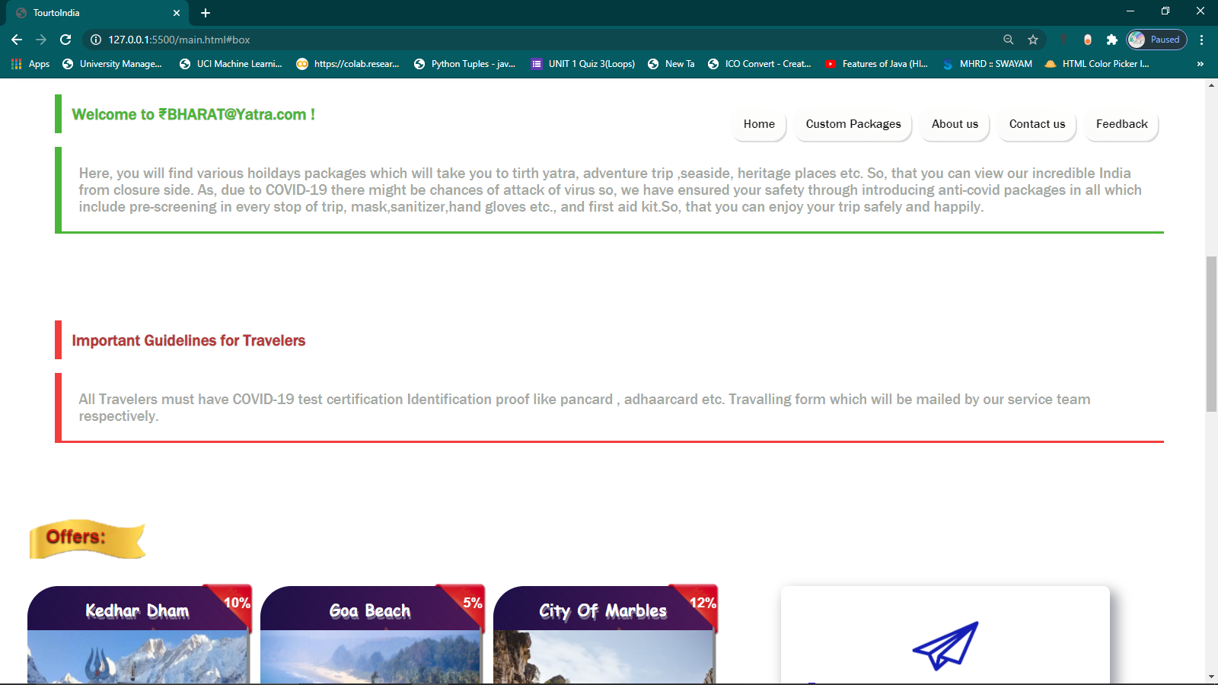

**Fig 4.1.2.2.1 : Covered only introduction and guidelines**

**Html Code:**

<section class="material">

    <div id="box"> //box1

        <br/>  <h1>Welcome to ₹BHARAT@Yatra.com ! </h1>

        <p>

      Here, you will find various hoildays packages which will take you to tirth yatra, adventure trip ,seaside, heritage places

      etc. So, that you can view our incredible India from closure side. As, due to COVID-19 there might be chances of attack of virus so, we have ensured your safety through introducing anti-covid packages in all which include

      pre-screening in every stop of trip, mask,sanitizer,hand gloves etc., and first aid kit.So, that you can enjoy your trip safely and happily.

        </p>

        <br/>

    </div>

    <div id="box2"> //box2

        <br/>

        <h1>Important Guidelines for Travelers </h1>

        <p>

      All Travelers must have COVID-19 test certification

      Identification proof like pancard , adhaarcard etc.

      Travalling form which will be mailed by our service team respectively.

        </p>

        <br/>

    </div>

</section>

* **CSS Code:**

/*BOX1*/

#box{

    display: block;

    padding-left: 20px;

    margin: 3rem;

}

#box h1{

    border-left: 10px solid rgba(30, 163, 7, 0.801) ;

    padding:15px;

    font-family: 'Franklin Gothic Medium', 'Arial Narrow', Arial, sans-serif;

    color:rgba(30, 163, 7, 0.801);

    margin-bottom: 20px;

}

#box p{

    border-left: 10px solid rgba(30, 163, 7, 0.801) ;

    font-size: 22px;

    border-bottom:  solid rgba(30, 163, 7, 0.801) ;

    padding:25px;

    font-family: 'Franklin Gothic Medium', 'Arial Narrow', Arial, sans-serif;

    color:rgba(142, 148, 141, 0.801);

    margin-bottom: 20px;

}

/*box2*/

#box2{

    display: block;

    padding-left: 20px;

    margin: 3rem;

}

#box2 h1{

    border-left: 10px solid rgba(238, 12, 12, 0.801) ;

    padding:15px;

    font-family: 'Franklin Gothic Medium', 'Arial Narrow', Arial, sans-serif;

    color:rgba(163, 7, 7, 0.801);

    margin-bottom: 20px;}

#box2 p{

    border-left: 10px solid rgba(238, 12, 12, 0.801) ;

    font-size: 22px;

    border-bottom:  solid rgba(238, 12, 12, 0.801) ;

    padding:25px;

    font-family: 'Franklin Gothic Medium', 'Arial Narrow', Arial, sans-serif;

    color:rgba(142, 148, 141, 0.801);

    margin-bottom: 20px;}

* + - 1. **Offers and subscribe container:**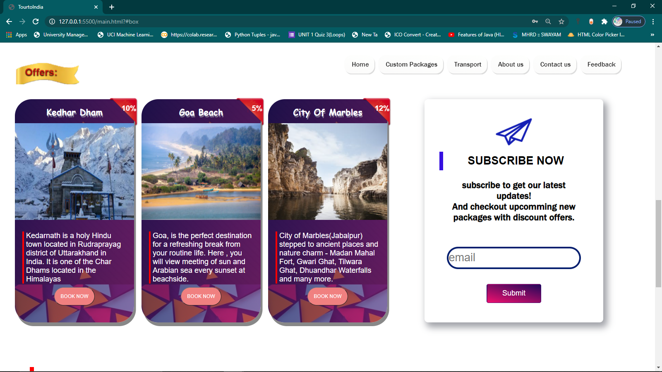

**Fig 4.1.2.3.1- Displayed offers and subscribe container**

**Html Code:**

<!-- <section id="packwithsub"> -->

    <div id="offers"><h1>Offers:</h1></div> //Offers

<section class="packages"> //Offer packages

    <div class="packageone">

          <div class="offer"> <img src="main/offersticker.png"/> <div class="discount"><p>10%</p></div></div>

          <h1> Kedhar Dham </h1>

        <img class="pic" src="main/kedarnath_3.jpg"/>

        <p>Kedarnath is a holy Hindu town located in Rudraprayag district of Uttarakhand in India. It is one of the Char Dhams located in the Himalayas</p>

        <button>BOOK NOW</button>

    </div>

     <div class="packageone">

        <div class="offer"> <img src="main/offersticker.png"/> <div class="discount"><p style="padding-left:5rem ;"> 5%</p></div></div>

        <h1>Goa Beach</h1>

         <img class="pic" src="main/beach_in_Goa_1511335579.webp"/>

        <p>Goa, is the perfect destination for a refreshing break

             from your routine life. Here , you will view meeting of sun and Arabian sea every sunset at beachside.  </p>

        <button>BOOK NOW</button>

    </div>

    <div class="packageone">

        <div class="offer"> <img src="main/offersticker.png"/> <div class="discount"><p>12%</p></div></div>

        <h1>City Of Marbles</h1>

        <img class="pic" src="main/Jabalpur.jpg"/>

        <p>City of Marbles(Jabalpur) stepped to ancient places and nature charm - Madan Mahal Fort, Gwari Ghat, Tilwara Ghat, Dhuandhar Waterfalls  and many more.</p>

        <button>BOOK NOW</button>

    </div>

<div id="subscriber"> //Subscriber

    <img src="main/subscribe.jpg"/>

    <h1>SUBSCRIBE NOW</h1>

    <P>subscribe to get our latest updates!

        <br/>

        And checkout upcomming new packages with discount offers.

    </P>

    <form>

    <label for="email"></label>

    <input type="email" placeholder="email" id="email" size="25" maxlength="40" />

    <button>Submit</button>

</form>

</div>

</section>

* **Css code:**

#offers{ /*OFFERS*/

margin:2rem ;

padding: 17px;

padding-left: 27px;

background-image: url("main/offers.png");

background-repeat:no-repeat;

font-size: small;

font-family: 'Franklin Gothic Medium', 'Arial Narrow', Arial, sans-serif;

color: rgba(236, 8, 8, 0.63);

text-shadow:  #200303 0.15px 2px 2.5px;

}

#packwithsub{ /* combining subscriber and package in single section*/

display: flex;

flex-direction: row;

flex-wrap: wrap;

}

/* OFFER PACKAGE*/

.packages{

display:flex;

flex-direction: row;

flex-wrap:wrap;

margin-left: 2rem;

margin-right: 2rem;

}

.packageone{

display: block;

box-shadow: 5px 10px #888888;

border-radius: 45px;

background:linear-gradient(108deg,rgba(20, 7, 77, 0.7) 0%,rgba(141, 25, 122, 0.603)100%) ,url("main/buttonsbk1.jpg") center transparent;

font-family: Arial, Helvetica, sans-serif;

height: 30rem;

width: 16rem;

margin-right: 1rem;

justify-content: center;

text-align: center;

color: white;

margin-bottom: 40px;

}

.packageone h1{

padding-top: 1rem;

font-family: cursive;

text-shadow: 2px 4px rgba(196, 211, 211, 0.452);

}

.packageone .offer{

width: 2px;

height: 2px;

transform: scale(0.101);

margin-left: 12.6rem;

z-index: 2;

margin-top: -4px;}

.packageone .discount{

font-weight: bold;

font-size: 10rem;

margin-top: -30rem;

margin-left: 15rem;}

.packageone .pic{

height: 13em;

margin-top: 15px;

margin-bottom: 15px;

width: 16.025rem;

position: relative;

}

.packageone p{

margin: 0.5rem;

margin-left:1rem ;

border-left:5px solid red;

padding-left:5px;

text-align: left;

margin-right: 1rem ;

color: white;

}

.packageone button{

padding: 15px;

margin-top: 0rem;

border-radius: 35px ;

color:white;

background-color:lightcoral;

background-attachment: fixed;

}

.packageone button:hover{

background-color: red;

font-size: 20px;

font-family: 'Franklin Gothic Medium', 'Arial Narrow', Arial, sans-serif;

}

.packageone:hover{

text-shadow: 0px 0px;

color: wheat;

transform: scale(1.05);

}

.subscribe{

border-left: 5px solid red;

border-radius: 0.5px 0.5px ;

}

/* Subscriber*/

#subscriber{

margin-left: 4em;

background-color:white ;

border-radius:10px ;

padding:2em;

font-family:'Segoe UI', Tahoma, Geneva, Verdana, sans-serif;

justify-content: center;

text-align:center;

box-shadow: 8px 10px 18px 3px rgba(139, 141, 148, 0.829);

padding-bottom: 4em;

width: 24em;

height: 30em;

box-sizing:border-box;

}

#subscriber img{

width: 200px;

}

#subscriber h1{

padding: 0.25em;

font-size: 30px;

border-left:10px solid rgb(54, 16, 224);

}

#subscriber p{

padding: 1em;

font-weight: bold;

font-family:'Franklin Gothic Medium', 'Arial Narrow', Arial, sans-serif;

font-size:25px;

}

#subscriber input{

margin: 1rem;

margin-top: 2rem;

border-radius: 30px 30px;

border: 5px solid  rgba(4, 29, 110, 0.993);

width: 18rem;

height: 3rem;

font-size: 30px;

}

#subscriber button{

padding: 12px 40px ;

margin-top: 1rem;

background:linear-gradient(15deg,rgb(241, 16, 110) 0%,rgb(33, 8, 90)100%);

border:2px solid  rgba(28, 8, 119, 0.63);

border-radius: 5px;

color: white;

font-size: 20px;

}

#subscriber button:hover{

transform: scale(1.15);

}

* + - 1. **About us , Contact us and Share us:**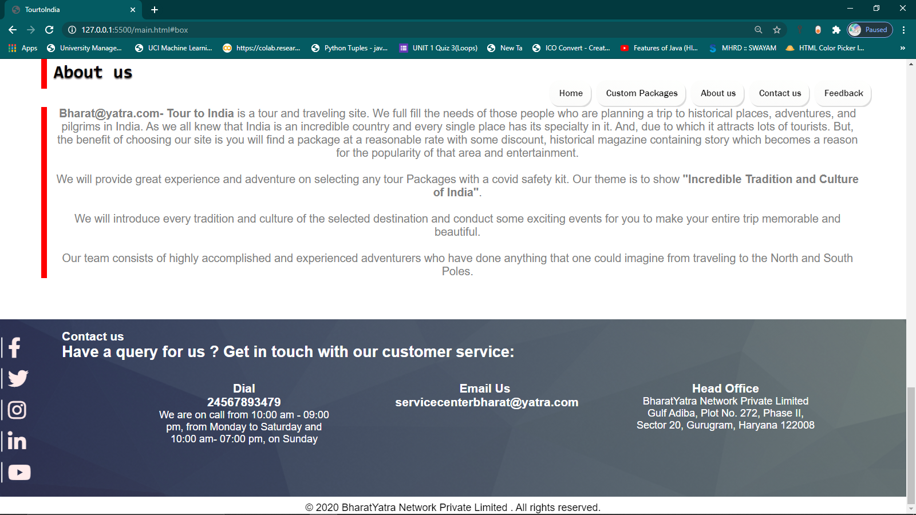

**Fig 4.1.2.4.1 Displaying last part of home page**

* **Html code:**

<section id="aboutus"> //About us

    <h1>About us</h1>

   <p> <b>Bharat@yatra.com- Tour to India </b>is a tour and traveling site. We full fill the needs of those people who are planning a trip to historical places, adventures, and pilgrims in India.

As we all knew that India is an incredible country and every single place has its specialty in it. And, due to which it attracts lots of tourists. But, the benefit of choosing our site is you will find a package at a reasonable rate with some discount, historical magazine containing story which becomes a reason for the popularity of that area and entertainment.

<br/><br/>

    We will provide great experience and adventure on selecting any tour Packages with a covid safety kit. Our theme is to show <b>"Incredible Tradition and Culture of India"</b>.

    <br/><br/>

    We will introduce every tradition and culture of the selected destination and conduct some exciting events for you to make your entire trip memorable and beautiful.

    <br/><br/>

    Our team consists of highly accomplished and experienced adventurers who have done anything that one could imagine from traveling to the North and South Poles.

    </p>

</section>

<section id="cont" >

    <div id="contactus"> //Contact us

    <h1>Contact us</h1>

    <h2>Have a query for us ? Get in touch with our customer service:</h2>

    <ul>

        <li><div class="contactusbox">

            <h3>Dial </h3>

            <h3>24567893479</h3>

            <p>We are on call from 10:00 am - 09:00 pm,

                 from Monday to Saturday and 10:00 am- 07:00 pm, on Sunday</p>

                </div>

        </li>

        <li> <div class="contactusbox">

             <h3>Email Us</h3>

                 <h3>servicecenterbharat@yatra.com</h3>

                 </div>

        </li>

        <li>    <div class="contactusbox">

               <h3> Head Office</h3>

                <p>BharatYatra Network Private Limited Gulf Adiba,

                     Plot No. 272, Phase II, Sector 20, Gurugram, Haryana 122008

                </p></div>

        </li>

    </ul>

</div>

              <div class="icon-bar" > //Share us

            <a href='#' class='facebook' target='_blank'>

                click here to visit<i class=" fab fa-facebook-f"></a></i>

            <a href='#' class='twitter' target='_blank'>

                click here to visit<i class=" fab fa-twitter"></i>

            </a>

            <a href='https://www.instagram.com/vinodthapa55/' class='instagram' target='_blank'>

                click here to visit<i class="fab fa-instagram"></i>

            </a>

            <a href='' class='linkedin' target='_blank'>

                click here to visit<i class="fab fa-linkedin-in"></i>

            </a>

            <p id="icon"><a href='https://www.youtube.com/thapatechnical' class='youtube' target='_blank'>

            click here to visit<i class=" fab fa-youtube"></i></a>

            </p>

        </div>

</section>

<section class="footer"> //Footer

       <div ><P>&COPY; 2020 BharatYatra Network Private Limited . All rights reserved.</P></div>

</section>

    </section>

    </section>

* CSS Code:

  /* ABOUT US*/

#aboutus{

 margin:3em;

 /* transform: ; */

 padding:1rem;

}

#aboutus h1{

    border-left: 12px solid red;

    /* border-bottom: 4px solid red; */

    font-family:monospace;

    font-size: 35px;

    padding: 12px;

    margin-bottom: 1em;

    font-weight:bold;

    /* font-stretch:narrower; */

    text-shadow: #554a4a 0.15px 2px 2.5px;

    }

    #aboutus p{

        padding-left: 900px;

        padding-right: 100px;

        padding-inline-end: 10px;

        text-align: center;

        font-family: Arial, Helvetica, sans-serif;

        font-size: 22px;

        color:grey;

    padding-left:15px;

    border-left: 12px solid red;

    }

  /* CONTACT US*/

    #cont{

        background:  linear-gradient(108deg,rgba(50, 50, 51, 0.5) 0%,rgba(126, 131, 79, 0.5)100%) ,url("MAIN/contactus.jpg") no-repeat transparent;

       background-size: cover;

       width: 100%;

       height: 18%;

    }

    #contactus{

       padding-top: 1rem;

       margin-left: 4rem;

       color: white;

       padding-left:2rem;

       margin-bottom: 10px;

       display: flex;

       flex-direction: column;

       padding-bottom: 5rem;

    }

    #contactus ul{

       list-style: none;

       font-family: 'Franklin Gothic Medium', 'Arial Narrow', Arial, sans-serif;

        margin-left: 3rem;

    }

    #contactus ul li{

       text-align:center;

       float: left;

       padding-top:2rem ;

       margin-left: 6rem;

       width: 22%;

    }

  /* SHARE US */

.icon-bar {

    position: absolute;

    margin-top: -9rem;

    transform: translateY(-50%);

    -webkit-transform: translateY(-50%);

    -ms-transform: translateY(-50%);

    z-index: 50;

}

.icon-bar a {

    text-decoration: none;

    width: 210px;

    color: #fff;

    display: flex;

    border-radius: 15px;

    justify-content: flex-end;

    align-items: center;

    padding: 5px;

    margin-top: 0.2rem;

    font-size: 20px;

    transform: translateX(-140px);

    -webkit-transform: translateX(-140px);

    -ms-transform: translateX(-140px);

    transition: all 0.5s linear;

    -webkit-transition: all 0.5s linear;

    -ms-transition: all 0.5s linear;

}

#icon:hover{

    color: white;

}

    }

.icon-bar .facebook:hover {

    background: #3b5998;

}

.icon-bar .twitter:hover{

    background: #00aced;

    ;

}

.icon-bar .instagram:hover {

    background: #e4405f;

}

.icon-bar .youtube:hover{

    background: #cd201f;

}

.icon-bar .linkedin:hover{

    background: #0077B5;

}

 {

}

.icon-bar a i {

    border-left:3px solid white;

    padding-left: 10px;

   margin-left: 10px;

   width: 70px;

    color: rgb(255, 235, 235);

    font-size: 40px !important;

    animation: letszoom 3s linear alternate-reverse infinite;

}

@keyframes letszoom {

    from {

        transform: scale(0.8);

    }

    to {

        transform: scale(1);

    }

}

a:hover {

    transform: translateX(0);

    -webkit-transform: translateX(0);

    -ms-transform: translateX(0);

    color: white ;

  }

/*FOOTER*/

   .footer{

        position: relative;

        text-align: center;

        bottom: 0;

* + 1. **Custom package (Adventure** 🡪 **Manali)**
       1. **Manali Cover page-**

Here, background is set on auto slide show amd open button is provided to proceed to view details of tour package . 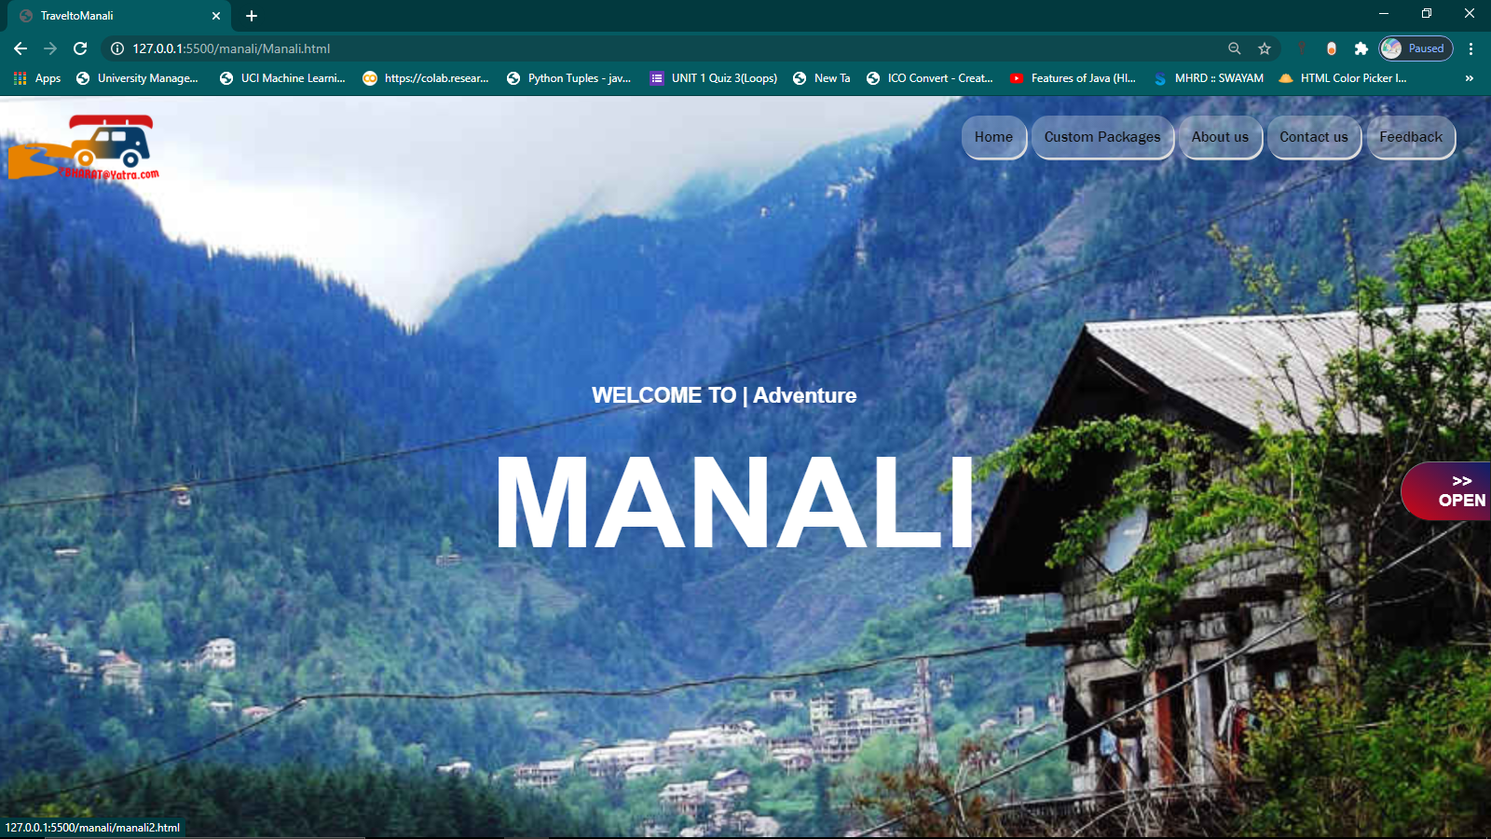

**Fig 4.1.3.1.1 Displaying the views of manali**

* **HTML Code:**

<section id ="background"> //Background

        <ul class="cb-slideshow"> //List of slide show

            <li><span>Image 01</span></li>

            <li><span>Image 02</span></li>

            <li><span>Image 03</span></li>

            <li><span>Image 04</span></li>

            <li><span>Image 05</span></li>

            <li><span>Image 06</span></li>

        </ul>

        <br/>

        <nav>  <img src="../Main/logo1.png"/> //navebar

            <div id = "container">

                <ul>

                    <a href="../main.html#background"><li>Home</li></a>

                    <li>Custom Packages

                        <ul>

                            <li>Adventure

                            <ul>

                                <a href="#"><li>Manali</li></a>

                                <li>Pangonge</li>

                            </ul>

                            </li>

                            <li>seaside

                                <ul>

                                    <li>Bilal</li>

                                    <li>Ahmad</li>

                                    <li>Arslam</li>

                                </ul>

                            </li>

                        </ul>

                    </li>

                    <a href="../main.html#aboutus"><li>About us</li></a>

                    <a href="../main.html#contactus"><li>Contact us</li></a>

                    <a href="../main/feedback.html"><li>Feedback</li></a>

                </ul>

            </div>

        </nav>

        <div id="heading"> //heading

            <h3> WELCOME TO | Adventure</h3>

            <h1>MANALI</h1>

            <br/>

        </div >

    <a href="manali2.html"><button id="open" >>> OPEN</button></a>

    </section>

* **CSS Code:**

*{

    margin: 0;

    padding: 0;

}

html{

    scroll-behavior: smooth;

}

/*NAVBAR*/

#container {

    margin-left: 57rem;

}

#container ul{

                list-style:none;

                position: fixed;

            }

            #container ul li{

                background:linear-gradient(15deg,rgba(240, 239, 238, 0.281) 0%,rgba(253, 255, 250, 0.281)100%) ,transparent;

               padding-left: 15px;

               padding-right:15px ;

               margin-left: 7px;

                border-radius: 20px;

                box-shadow:   2px 3px gainsboro;

                height: 50px;

                line-height: 50px;

                text-align: center;

                float: left;

                color:rgb(14, 13, 13);

                font-size: 18px;

                font-family: 'Franklin Gothic Medium', 'Arial Narrow', Arial, sans-serif;

                font-style: bold;

                position:relative;

            }

            #container ul li:hover {

                background-image:url('buttonsbk1.jpg');

            color: whitesmoke;

            }

            #container ul ul{

                display:none;

            }

            #container ul ul li{

                width:120px;

                margin-left:-12px;

            }

            #container ul li:hover > ul{

                display:block;

                width:120px;

                position:relative;

            }

            #container ul ul ul{

                margin-left:148px;

                top:0px;

                position: sticky;

                     margin-top:-45px ;

            }

            #background img{

                margin-top: -3.1rem;

                float: left;

                margin-right: 1rem;

                position: absolute;

            }

/*SLIDE SHOW*/

.cb-slideshow,

.cb-slideshow:after {

    position: fixed;

    width: 100%;

    height: 100%;

    top: 0px;

    left: 0px;

    z-index: 0;

}

.cb-slideshow:after {

    content: '';

    /* background: transparent url(manali.jpg) repeat top left; */

}

.cb-slideshow li span {

    width: 100%;

    height: 100%;

    position: absolute;

    top: 0px;

    left: 0px;

    color: transparent;

    background-size: cover;

    background-position: 50% 50%;

    background-repeat: none;

    opacity: 0;

    z-index: 0;

    -webkit-backface-visibility: hidden;

    -webkit-animation: imageAnimation 36s linear infinite 0s;

    -moz-animation: imageAnimation 36s linear infinite 0s;

    -o-animation: imageAnimation 36s linear infinite 0s;

    -ms-animation: imageAnimation 36s linear infinite 0s;

    animation: imageAnimation 36s linear infinite 0s;

}

.cb-slideshow li div {

    z-index: 1000;

    position: absolute;

    bottom: 10px;

    left: 0px;

    width: 100%;

    text-align: right;

    opacity: 0;

    -webkit-animation: titleAnimation 36s linear infinite 0s;

    -moz-animation: titleAnimation 36s linear infinite 0s;

    -o-animation: titleAnimation 36s linear infinite 0s;

    -ms-animation: titleAnimation 36s linear infinite 0s;

    animation: titleAnimation 36s linear infinite 0s;

    padding: 0 30px;

    line-height: 120px;

}

.cb-slideshow li:nth-child(1) span { background-image: url(manali.jpg) ;}

.cb-slideshow li:nth-child(2) span {

    background-image: url(manali3.jpg);

    -webkit-animation-delay: 6s;

    -moz-animation-delay: 6s;

    -o-animation-delay: 6s;

    -ms-animation-delay: 6s;

    animation-delay: 6s;

}

.cb-slideshow li:nth-child(3) span {

    background-image: url(manali2.jpg);

    -webkit-animation-delay: 12s;

    -moz-animation-delay: 12s;

    -o-animation-delay: 12s;

    -ms-animation-delay: 12s;

    animation-delay: 12s;

}

.cb-slideshow li:nth-child(4) span {

    background-image: url(manalihotel.jpg);

    -webkit-animation-delay: 18s;

    -moz-animation-delay: 18s;

    -o-animation-delay: 18s;

    -ms-animation-delay: 18s;

    animation-delay: 18s;

}

.cb-slideshow li:nth-child(5) span {

    background-image: url(camping-package-tour-manali.jpg);

    -webkit-animation-delay: 24s;

    -moz-animation-delay: 24s;

    -o-animation-delay: 24s;

    -ms-animation-delay: 24s;

    animation-delay: 24s;

}

.cb-slideshow li:nth-child(6) span {

    background-image: url(Basic-Mountaineering.jpg);

    -webkit-animation-delay: 30s;

    -moz-animation-delay: 30s;

    -o-animation-delay: 30s;

    -ms-animation-delay: 30s;

    animation-delay: 30s;

}

//Making flexible in other browsing platform through using key frames

@-webkit-keyframes imageAnimation {

    0% {

        opacity: 0;

        -webkit-animation-timing-function: ease-in;

    }

    8% {

        opacity: 1;

        -webkit-transform: scale(1.05);

        -webkit-animation-timing-function: ease-out;

    }

    17% {

        opacity: 1;

        -webkit-transform: scale(1.1) ;

    }

    25% {

        opacity: 0;

        -webkit-transform: scale(1.1);

    }

    100% { opacity: 0 }

}

@-moz-keyframes imageAnimation {

    0% {

        opacity: 0;

        -moz-animation-timing-function: ease-in;

    }

    8% {

        opacity: 1;

        -moz-transform: scale(1.05);

        -moz-animation-timing-function: ease-out;

    }

    17% {

        opacity: 1;

        -moz-transform: scale(1.1);

    }

    25% {

        opacity: 0;

        -moz-transform: scale(1.1) ;

    }

    100% { opacity: 0 }

}

@-o-keyframes imageAnimation {

    0% {

        opacity: 0;

        -o-animation-timing-function: ease-in;

    }

    8% {

        opacity: 1;

        -o-transform: scale(1.05);

        -o-animation-timing-function: ease-out;

    }

    17% {

        opacity: 1;

        -o-transform: scale(1.1);

    }

    25% {

        opacity: 0;

        -o-transform: scale(1.1);

    }

    100% { opacity: 0 }

}

@-ms-keyframes imageAnimation {

    0% {

        opacity: 0;

        -ms-animation-timing-function: ease-in;

    }

    8% {

        opacity: 1;

        -ms-transform: scale(1.05);

        -ms-animation-timing-function: ease-out;

    }

    17% {

        opacity: 1;

        -ms-transform: scale(1.1) ;

    }

    25% {

        opacity: 0;

        -ms-transform: scale(1.1);

    }

    100% { opacity: 0 }

}

@keyframes imageAnimation {

    0% {

        opacity: 0;

        animation-timing-function: ease-in;

    }

    8% {

        opacity: 1;

        transform: scale(1.05);

        animation-timing-function: ease-out;

    }

    17% {

        opacity: 1;

        transform: scale(1.1) ;

    }

    25% {

        opacity: 0;

        transform: scale(1.1) ;

    }

    100% { opacity: 0 }

}

/* Show at least something when animations not supported */

.no-cssanimations .cb-slideshow li span{

    opacity: 1;

}

@media screen and (max-width: 1140px) {

    .cb-slideshow li div h3 { font-size: 100px }

}

@media screen and (max-width: 600px) {

    .cb-slideshow li div h3 { font-size: 50px }

}

#heading /*HEADING*/

{ width: 100%;

 height: 41%;

        align-items: center;

    position:relative;

}

#heading h1{

    font-family:Arial, Helvetica, sans-serif;

    font-size: 150px;

    text-align: center;

    top: 0;

    color:WHITE;

    padding-top:28px;

    margin-left: -26px;

}

#heading h3{

    font-family:Arial, Helvetica, sans-serif;

    font-size:25px;

     text-align: center;

    margin-top: 320px;

    color:WHITE;

    margin-left: -50px;

}

/*OPEN*/

#open{

    margin-left: 83.5rem;

    margin-top: -8rem;

    position: absolute;

    padding-left: 40px;

    padding-top: 10px;

    padding-bottom: 10px;

    border-radius: 50px 0px 0px 50px ;

    background:rgba(238, 231, 232, 0.267);

    color: seashell;

    font-size: 20px;

    box-shadow: slategray;

}

#open:hover{

    background:linear-gradient(35deg,rgb(219, 4, 15) 0%,rgb(8, 31, 107)100%);

    color:white;

    font-weight: bold;

}

* + - 1. **Manali tour package page**

* + - * 1. **Article and Map**

It is divided into three sections as per the requirement of content.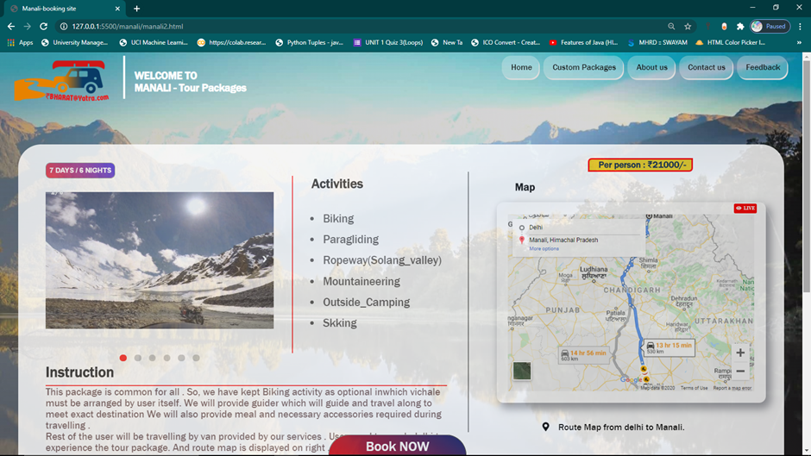

**Fig 4.1.3.2.1:Displaying first half of tour package template**

* **HTML Code:**

<nav id="background2">

   <div id="#logo">

    <img src="../Main/logo1.png"/>

    </div>

           <div id="heading">

        <h3>WELCOME TO</h3>

        <h3><span>MANALI</span> - Tour Packages</h3></div>

            <div id = "container">

                <ul>

                    <a href="../main.html#background"><li>Home</li></a>

                    <li>Custom Packages

                      <ul>

                    <li>Adventure

                      <ul>

                          <a href="Manali.html"><li>Manali</li></a>

                    <li>Goa beach</li>

                  </ul>

                  </li>

                  <li> Piligrams

                      <ul>

                          <li>KedarDham</li>

                          <li>Buddha</li>

                      </ul>

                  <li>Heritage

                      <ul>

                          <li>Rajasthan</li>

                          <li>Jabalpur</li>

                      </ul>

                  </li>

                        </ul>

                    </li>

                    <a href="../main.html#aboutus"><li>About us</li></a>

                    <a href="../main.html#contactus"><li>Contact us</li></a>

                    <a href="../main/feedback.html"><li>Feedback</li></a>

                </ul>

              </div>

         </nav>

       <section id="page">

            <section id="sections" >

        <div id="info">

               <div class="slideshow-container">

    <div >

       <button id="day">7 DAYS / 6 NIGHTS</button> //day / night button

            <div class="mySlides fade">

              <div class="numbertext">1 / 6</div>

              <img src="leh-to-manali-hd.jpg" style="width:100%">

            </div>

            <div class="mySlides fade"> //slideshow

              <div class="numbertext">2 / 6</div>

              <img src="parasuit.jpg" style="width:100%">

            </div>

            <div class="mySlides fade">

                <div class="numbertext">3 / 6</div>

                <img src="manaliactivities.jpg" style="width:100%">

              </div>

              <div class="mySlides fade">

                <div class="numbertext">4 / 6</div>

                <img src="Basic-Mountaineering.jpg" style="width:100%">

              </div>

              <div class="mySlides fade">

                <div class="numbertext"> 5 / 6</div>

                <img src="camping-package-tour-manali.jpg" style="width:100%">

              </div>

            <div class="mySlides fade">

              <div class="numbertext">6 / 6</div>

              <img src="manali2.jpg" style="width:100%">

            </div>

            <a class="prev" onclick="plusSlides(-1)">&#10094;</a>

            <a class="next" onclick="plusSlides(1)">&#10095;</a>

            <div id="activitylist">

                            <h1> Activities</h1>

                            <div id="xline"></div>

                <ul>

                <li class="texts" onclick="currentSlide(1)"> Biking</li>  //list of activites

                <li class="texts" onclick="currentSlide(2)"> Paragliding</li>

                <li class="texts" onclick="currentSlide(3)">Ropeway(Solang_valley)</li>

                <li class="texts" onclick="currentSlide(4)"> Mountaineering</li>

                <li class="texts" onclick="currentSlide(5)"> Outside_Camping</li>

                <li class="texts" onclick="currentSlide(6)">Skking</li>

                </ul>  </div>

            </div>

            <div style="text-align:center">

              <span class="dot" onclick="currentSlide(1)"></span>  // dots attached with slide

              <span class="dot" onclick="currentSlide(2)"></span>

              <span class="dot" onclick="currentSlide(3)"></span>

              <span class="dot" onclick="currentSlide(4)"></span>

              <span class="dot" onclick="currentSlide(5)"></span>

              <span class="dot" onclick="currentSlide(6)"></span>

            </div>

              <div id="instruct">

            <h2>Instruction</h2>

            <p>This package is common for all . So, we have kept

                Biking activity as optional inwhich vichale must be arranged by user itself.

                We  will provide guider which will guide and travel along to meet exact destination

                We will also provide meal and necessary accessories required during travelling .

                <br/>Rest of the user will be travelling by van provided by our services .

                User need to reach delhi to experience the tour package.

                And route map is displayed on right .

            </p>

            </div>

              </div>

            </div>

            <div id="mapframe">

              <p id="payment">Per person : ₹21000/-</p>

                <h1>Map</h1> //map

          <div id="map">  <button id="live"><i class="fas fa-eye">&nbsp;&nbsp;LIVE</button></i>

            <iframe src="https://www.google.com/maps/embed?pb=!1m28!1m12!1m3!1d3522039.403927751!2d74.6178706477591!3d30.45051086120232!2m3!1f0!2f0!3f0!3m2!1i1024!2i768!4f13.1!4m13!3e0!4m5!1s0x390cfd5b347eb62d%3A0x37205b715389640!2sDelhi!3m2!1d28.7040592!2d77.10249019999999!4m5!1s0x39048708163fd03f%3A0x8129a80ebe5076cd!2sManali%2C%20Himachal%20Pradesh!3m2!1d32.2431872!2d77.1891761!5e0!3m2!1sen!2sin!4v1604688328957!5m2!1sen!2sin" frameborder="0"  allowfullscreen="" aria-hidden="false" tabindex="0"></iframe>

          </div>

          <br/> <div id="mapdes">

                 <p>  <i class="fas fa-map-marker-alt"></i>

                     &nbsp;&nbsp; Route Map from delhi to Manali.</p>

                </div>

            </div>

    </section>

* **Javascript Code:**

    <script>

        var slideIndex = 1;

        showSlides(slideIndex);

       // Slide show function

         function plusSlides(n) {

           showSlides(slideIndex += n);

        }

        function currentSlide(n) {

          showSlides(slideIndex = n);

        }

        function showSlides(n) {

          var i; //slideshow with dots

          var slides = document.getElementsByClassName("mySlides");

          var dots = document.getElementsByClassName("dot");

          if (n > slides.length) {slideIndex = 1}

          if (n < 1) {slideIndex = slides.length}

          for (i = 0; i < slides.length; i++) {

              slides[i].style.display = "none";

          }

          for (i = 0; i < dots.length; i++) {

              dots[i].className = dots[i].className.replace(" active", "");

          }

          slides[slideIndex-1].style.display = "block";

          dots[slideIndex-1].className += " active";

        }

          </script>

* **CSS Code:**

*{

   margin: 0px;

    padding: 0;

    box-sizing: border-box;

}

}

html{

    scroll-behavior: smooth;

}

#background2{

    display: flex;

    flex-direction: row;

     margin-top: 0.4rem;

}

#container {

    flex: 85%;

    margin-left: 62%;

      position: absolute;

      z-index: 50;

}

#heading{

    flex:9%;

    margin-left: 5rem;

    padding-left: 20px ;

    border-left:5px solid white ;

    color: white;

    font-family: 'Franklin Gothic Medium', 'Arial Narrow', Arial, sans-serif;

    margin-bottom:4rem;

    padding-top:1.5rem ;

}

#container ul{

               list-style:none;

               position: fixed;

           }

           #container ul li{

               background:linear-gradient(15deg,rgba(240, 239, 238, 0.281) 0%,rgba(253, 255, 250, 0.281)100%) ,transparent;

              padding-left: 20px;

              padding-right:15px ;

              margin-left: 10px;

               border-radius: 20px;

               box-shadow:   2px 3px gainsboro;

               height: 50px;

               line-height: 50px;

               text-align: center;

               float: left;

               color:rgb(14, 13, 13);

               font-size: 18px;

               font-family: 'Franklin Gothic Medium', 'Arial Narrow', Arial, sans-serif;

               font-style: bold;

               position:relative;

           }

           #container ul li:hover {

               background-image:url('buttonsbk1.jpg');

           color: whitesmoke;

           }

           #container ul ul{

               display:none;

           }

           #container ul ul li{

               width:120px;

               margin-left:-12px;

           }

           #container ul li:hover > ul{

               display:block;

               width:120px;

               position: relative;;

           }

           #container ul ul ul{

               margin-left:113px;

               top:0px;

               position: relative;

               margin-top: -2.3rem;

           }

            #background2 img{

                flex:6%;

               margin-top:-3rem;

               margin-right: -4rem;

               top:0;

                margin-left: 1rem;

                position: relative;

                width: 230px;

            }

body{

    background:linear-gradient(55deg,rgba(138, 135, 135, 0.521) 0%,rgba(47, 47, 53, 0.164)100%) ,  url("manali.jpg");

    background-size:  cover;

    background-repeat:  no-repeat;

    background-attachment: fixed;

    font-family: 'Franklin Gothic Medium', 'Arial Narrow', Arial, sans-serif;

}

#page{

    margin-top: 1rem;

    background-color: white;

    border-radius: 50px 50px;

    margin-left: 40px;

    margin-right:40px;

    opacity: 0.8;

    display: flex;

    flex-direction: column;

    position: relative;

}

#info{

    position: relative;

    margin-top: 2rem;

    background-color: white;

    border-radius: 50px 50px;

    margin-left: 40px;

    margin-right:40px;

    opacity: 0.8;

    flex: 60%;

}

#mapframe{

       flex: 40%;

      margin-right: 2rem;

    margin-top: 3rem;

    margin-left: 1rem;

    padding-left: 3rem;

    border-left: 3px solid gray;

    margin-bottom: 2rem;

}

#mapframe h1{

    font-family: 'Franklin Gothic Medium', 'Arial Narrow', Arial, sans-serif;

    color: rgb(14, 13, 13);

    margin: 1rem;

    margin-left: 2rem;

}

#map{

    height: 440px;

    width:590px;

    position: relative;

    background-color: rgb(255, 255, 255);

    opacity: 1;

    border-radius: 15px;

    box-shadow: 8px 10px 18px 3px rgba(139, 141, 148, 0.829);

   }

   #live{ //live button

       background-color: red;

       padding: 5px;

       width: 50px;

    border-radius: 3px;

    color: white;

    font-weight: bolder;

    border-style: inherit;

    font-size: 10px;

    position:absolute;

    margin-top: 3px;

    margin-left: 52em;

   }

iframe{

    margin-top:1.3em ;

    height: 388px;

    width: 540px;

    margin-left: 1.2rem;

    opacity: 1;

   background-color:solid white ;

    border:0;

}

#mapdes{

    margin-left:5rem ;

    margin-top: 1rem;

}

/* #info h1{

    margin-top:2rem;

    padding-top:2em;

    margin-left: ;

} */

/* frame{ //mapframe

    min-height:100vh;

    background-color:#a89cde;

    display:flex;

    justify-content:center;

    align-items:center;

  } */

  .mySlides {display: none}

.mySlides img {vertical-align:left;

    height: 15rem;

    margin-top:1.5rem;

}

/* Slideshow container */

.slideshow-container {

  width: 500px;

  height: 450px;

  position: relative;

  margin-left: 1rem;

}

#day{

    padding: 7px;

    border-radius: 10px;

    background: linear-gradient(55deg,rgb(245, 11, 22) 0%,rgb(28, 14, 223)100%);

    color: white;

    font-weight: bold;

    border-style: solid;

    font-size: 15px;

}

#mapframe #payment{

    margin-left:10rem;

    margin-right: 8rem;

    margin-top: -1.5rem;

    font-family: 'Franklin Gothic Medium', 'Arial Narrow', Arial, sans-serif;

    color:rgb(9, 34, 66);

    font-weight: bolder;

    border-radius: 8px 0px 8px 0px ;

    border-style: solid ;

    padding-left: 20px;

    border-color:  rgb(255, 0, 0);

    background-color: rgb(236, 204, 25);

}

/* Next & previous buttons */

.prev, .next {

  cursor: pointer;

  position: absolute;

  top: 50%;

  width: auto;

  padding: 16px;

  margin-top: -42px;

  color: white;

  font-weight: bold;

  font-size: 18px;

  transition: 0.6s ease;

  border-radius: 0 3px 3px 0;

  user-select: none;

}

/* Position the "next button" to the right */

.next {

  right: 0;

  border-radius: 3px 0 0 3px;

}

/* On hover, add a black background color with a little bit see-through */

.prev:hover, .next:hover {

  background-color: rgba(0,0,0,0.8);

}

#activitylist{

    margin-left: 27rem;

    margin-top: -17rem;

    color: rgb(59, 56, 56);

    font-size: 25px;

    padding-left: 4rem;

    padding-top: -1rem;

    border-left: 3px solid red;

    padding-bottom: 2rem;

    font-family: 'Franklin Gothic Medium', 'Arial Narrow', Arial, sans-serif;

}

.texts{

    padding: 5px;

    margin-left: -1rem;

    margin-bottom: 7px;

}

#activitylist h1{

    margin-left: -2rem;

    color: black;

    margin-bottom: 2rem;

}

#activitylist xline{

    padding: 20px;

    border:1px solid red;

}

active, .texts:hover{

    color: red;

    transform: scale(1.2);

    cursor: pointer;

}

/* Caption text */

/* .text {

  color: #f2f2f2;

  font-size: 15px;

  padding: 8px 12px;

  position: absolute;

  bottom: 8px;

  width: 100%;

  text-align: center;

} */

/* Number text (1/3 etc) */

.numbertext {

  color: #f2f2f2;

  font-size: 12px;

  padding: 8px 12px;

  position: absolute;

  top: 0;

  margin-top: 2.5rem;

  font-weight: bold ;

}

/* The dots/bullets/indicators */

.dot {

  cursor: pointer;

  height: 15px;

  width: 15px;

  margin: 0px 6px;

  background-color: #bbb;

  border-radius: 50%;

  display: inline-block;

  transition: background-color 0.6s ease;

}

.active ,.dot:hover {

  background-color: #ff0000;

  color: #ff0000;

}

/* Fading animation */

.fade {

  -webkit-animation-name: fade;

  -webkit-animation-duration: 1.5s;

  animation-name: fade;

  animation-duration: 1.5s;

}

#instruct{

    width: 45rem;

    background: none;

    font-family: 'Franklin Gothic Medium', 'Arial Narrow', Arial, sans-serif;

    font-size: 22px;

}

#instruct h2{

    border-bottom: 3px solid red;

    margin-right: 20px;

    padding-bottom: 10px;

}

#instruct p{

    color:  rgba(41, 3, 3, 0.781);

}

#sections{

    display: flex;

    flex-direction: row;

    position: relative;

}

* + - * 1. **Facilities , hotels and schedule plan**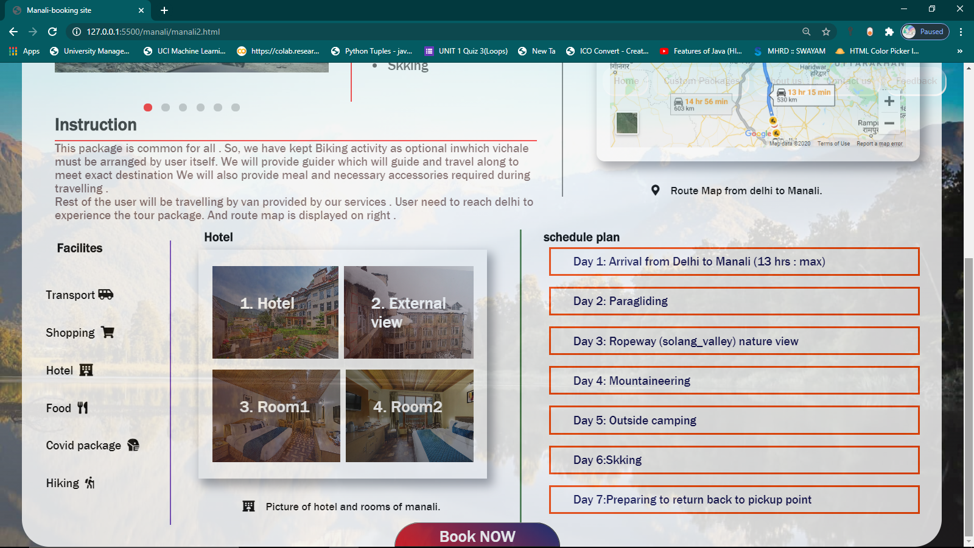

**Fig 4.1.3.2.2 : Displaying last section of manali tour package**

**HTML Code:**

<section  id="section2">

    <div id="facilites">

        <h1>Facilites</h1> //facilities

        <ul id="faclit">

       <li>Transport&nbsp;<i class="fas fa-shuttle-van"></i></li> <br/>

        <li>Shopping &nbsp;<i class="fas fa-shopping-cart"> </i> </li>

         <br/><li>Hotel &nbsp;<i class="fas fa-hotel"></li></i>

         <br/><li>Food &nbsp;<i class="fas fa-utensils"></li></i>

         <br/><li>Covid package &nbsp;<i class="fas fa-head-side-mask"></li></i>

         <br/> <li>Hiking &nbsp;<i class="fas fa-hiking"> </li></i>

        </ul>

    </div>

    <div id="hotels">

        <h1 style="padding: 10px;">Hotel</h1> //hotelframes

        <div id="hotelframe">

             <div>

            <duba id="one" ><p>1.&nbsp;Hotel&nbsp;&nbsp;&nbsp;&nbsp;<br/> </p></duba>

            <!-- <img src="hotel.jpg"/> -->

        <duba id="two"><p>2.&nbsp;External <br/>view</p></duba>

        <!-- <img src="exterior view.jpg"/> -->

        </div>

        <div>

            <duba id="three"><p>3.&nbsp;Room1<br/><br/></p></duba>

            <!-- <img src="classsic room-bed.jpg"/> -->

            <duba id="four"><p>4.&nbsp;Room2<br/><br/></p></duba>

            <!-- <img src="juniorsuite-bedroom.jpg"/> -->

        </div>

        </div>

    <p style="margin-left:4rem;margin-top: 2rem;"><i class="fas fa-hotel"></i> &nbsp;&nbsp;&nbsp;Picture of hotel and rooms of manali.</p>

    </div>

    <div id="schedule"> ///schedule plan

        <h1>schedule plan</h1>

        <p class="plan">Day 1: Arrival from Delhi to Manali (13 hrs : max)</p>

        <p class="plan">Day 2: Paragliding</p>

        <P class="plan">Day 3: Ropeway (solang_valley) nature view</P>

        <p class="plan">Day 4: Mountaineering</p>

        <p class="plan">Day 5: Outside camping</p>

        <p class="plan">Day 6:Skking  </p>

        <p class="plan">Day 7:Preparing to return back to pickup point</p>

    </div>

</section>

<button id="book">Book NOW</button>

* **CSS Code:**

#section2{

    display: flex;

    flex-direction: row;

    position: relative;

    margin-left: 1.2rem;

}

#section2 #facilites{

    flex:14%;

    margin-left: 2rem;

    margin-top: 2rem;

    padding-right: 1rem;

      border-right: 3px solid rgb(113, 70, 192);

    margin-right: 4.5rem;

    margin-bottom: 2rem;

    font-family: 'Franklin Gothic Medium', 'Arial Narrow', Arial, sans-serif;

}

#facilities i{

    margin-top: 1rem;

}

#faclit{

    list-style: none;

    margin-top: 3rem;

}

 #faclit li{

    margin-bottom: 1rem;

    padding-bottom: 2px;

    font-size: 22px;

    margin-left: -1rem;

}

#section2 #hotels{

    flex:35%;

    margin-top: 0.5rem;

    font-family: 'Franklin Gothic Medium', 'Arial Narrow', Arial, sans-serif;

    margin-left:-40px ;

    margin-bottom: 3rem;

}

#hotelframe div{

    display: flex;

    flex-direction: row;

    flex: 50%;

}

#hotels duba{

    flex:25%;

   padding:50px;

    margin-top: 0.5rem;

    margin-left: 0.25rem;

    margin-right: 0.25rem;

    margin-bottom: 0.5rem;

    background:linear-gradient(55deg,rgba(245, 11, 23, 0.287) 0%,rgba(28, 14, 223, 0.233)100%) ;

    font-size: 30px;

    color:white

}

#hotelframe{

    margin-bottom: 1rem;

    margin-right: 23.4rem;

    padding: 20px;

    box-shadow:8px 10px 18px 3px rgba(139, 141, 148, 0.829) ;

}

/* #hotelframe:hover{

    transform:scale(1.1);

} */

 #hotels duba:hover{

  transform: scale(1.9);

  color:#00000000;

cursor: pointer;

 background: #000000;

}

#hotelframe #one {

    background:linear-gradient(55deg,rgba(44, 3, 5, 0.692) 0%,rgba(51, 51, 61, 0.233)100%) , url("hotel.jpg");

    background-size: cover;

}

#hotelframe #two {

    background:linear-gradient(55deg,rgba(44, 3, 5, 0.692) 0%,rgba(51, 51, 61, 0.233)100%) , url("exterior\ view.jpg");

  background-size: cover;

}

#hotelframe #three {

    background:linear-gradient(55deg,rgba(44, 3, 5, 0.692) 0%,rgba(51, 51, 61, 0.233)100%) , url("classsic\ room-bed.jpg");

  background-size: cover;

}

#hotelframe #four  {

    background:linear-gradient(55deg,rgba(0, 0, 0, 0.692) 0%,rgba(51, 51, 61, 0.233)100%) , url("juniorsuite-bedroom.jpg");

  background-size: cover;

}

#hotelframe #one:hover {

    background-image: url("hotel.jpg");

    opacity: 1;

  background-size: cover;

}

#hotelframe #two:hover {

    background-image:url("exterior\ view.jpg");

  opacity: 1;

  background-blend-mode: normal;

  background-size: cover;

}

#hotelframe #three:hover {

    background-image: url("classsic\ room-bed.jpg");

  opacity: 1;

  background-size: cover;

}

#hotelframe #four:hover  {

    background-image: url("juniorsuite-bedroom.jpg");

  opacity: 1;

  background-size: cover;

}

#section2 #schedule{

    flex: 52%;

    margin-left: -20.4rem;

    margin-top: 1rem;

    padding-left: 2rem;

    border-left: 3px solid rgba(4, 78, 4, 0.746);

    margin-bottom: 2rem;

    font-family: 'Franklin Gothic Medium', 'Arial Narrow', Arial, sans-serif;

}

#schedule h1{

   }

#schedule p{

    border: 4px solid orangered;

    margin-left: 0.5rem;

    margin-right: 2rem;

    padding-bottom:10px ;

    padding-top:10px ;

    margin-top: 5px;

    font-size: 22px;

    padding-left: 40px;

    color: rgb(9, 9, 78);

    margin-bottom: 1rem;

}

#schedule p:hover{

    background-color: rgb(9, 100, 9);

    color: rgb(238, 231, 170);

    cursor: pointer;

    border-color: ;

    border-color: rgb(7, 78, 7);

}

#book{

    position: fixed;

    bottom:0;

    left:0;

   padding-left: 4rem;

   padding-right: 4rem;

   margin-left: 36rem;

   padding-top: 0.3rem;

   border-radius: 50px 50px 0%  0%   ;

   text-align: center;

   font-size: 30px;

   background: linear-gradient(35deg,rgb(219, 4, 15) 0%,rgb(8, 31, 107)100%);

   color: white;

   font-family: 'Franklin Gothic Medium', 'Arial Narrow', Arial, sans-serif;

}

#book:hover{

    transform: scaley(1.2);

    background: linear-gradient(35deg,rgb(22, 5, 71) 0%,rgb(218, 16, 16)100%);

    transition: 0.5s ease;

}

* + - * 1. **Booking page**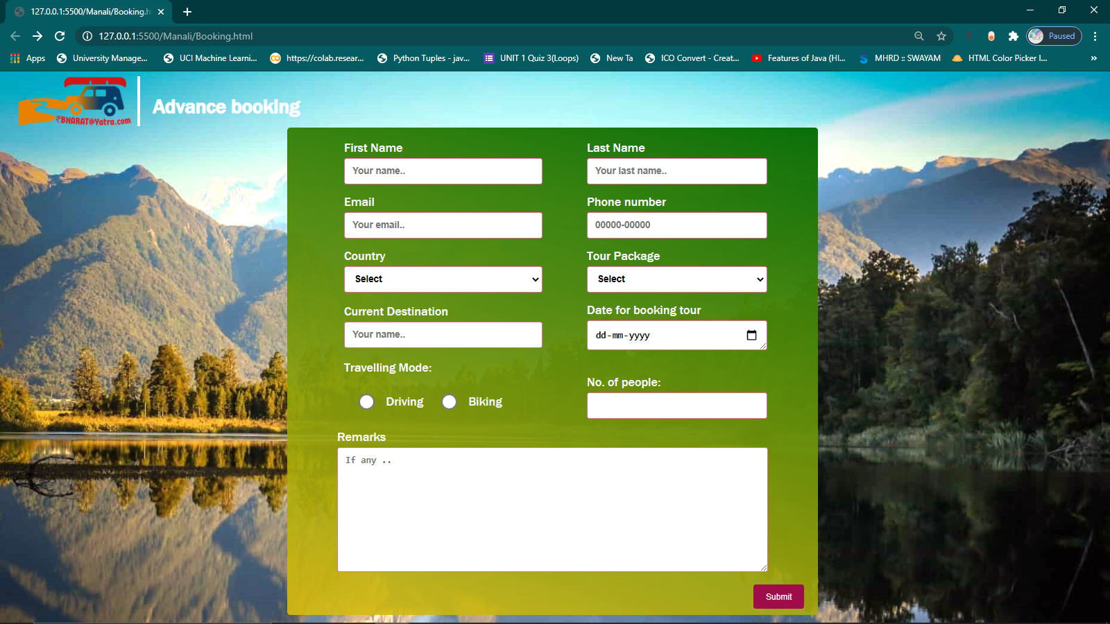

**Fig 4.1.3.2.3.1:This is site to book particular tour package**

* **HTML Code:**

<section>

        <nav id="background2">  <img src="../Main/logo1.png"/> //logo

       <h1 id="heading">Advance booking</h1></nav>

</nav>

<div class="contained"> //form

    <form onsubmit="return submitted()" >

  <table>

      <tr>

          <td>

              <label for="fname">First Name</label>

                 <input type="text" id="fname" name="firstname" placeholder="Your name.." required>

          </td>

          <td>

               <label for="lname">Last Name</label>

    <input type="text" id="lname" name="lastname" placeholder="Your last name.." required>

          </td>

      </tr>

      <tr>

        <td>

           <label for="Email"> Email</label>

    <input type="email" id="lname" name="Email" placeholder="Your email.." required>

        </td>

        <td>

            <label for="Phone no."> Phone number</label>

            <input type="tel" id="Phonenumber" name="Phone Number" pattern="[0-9]{5}-[0-9]{5}" placeholder="00000-00000" required>

        </td>

      </tr>

      <tr>

          <td>

            <label for="country">Country</label>

            <select id="country" name="country" required>

                <option >Select</option>

              <option >India</option>

              <option >Canada</option>

              <option >USA</option>

              <option >Australia</option>

            </select>

          </td>

          <td>

            <label for="country">Tour Package</label>

            <select id="country" name="country" placeholder="Select" required>

                <option >Select</option>

                <option >Manali</option>

              <option >Goa beach</option>

            </select>

          </td>

      </tr>

      <tr>

        <td>

            <label for="fname">Current Destination</label>

               <input type="text" id="fname" name="firstname" placeholder="Your name.." required>

        </td>

        <td>

             <label for="lname">Date for booking tour</label>

             <input type="date" id="date" required>

        </td>

    </tr>

    <tr >

            <td>Travelling Mode: </td> <tr><td ><input type="radio" class="mode"> Driving

                <input type="radio" class="mode" > Biking</td>

                <td >No. of people: <input type="number" min="0" id="age" required maxlength="3"></td>

    </tr>

</tr>

    <tr>

         </table>

    <label for="subject">Remarks</label>

    <textarea id="subject" name="subject" placeholder="If any .." style="height:200px" ></textarea>

        </tr>

    <button value="submit"   >Submit</button>

  </form>

</div>

</section>

* **CSS Code:**

<style>* {

    margin: 0;

    padding: 0;

    box-sizing: border-box;} //background setup

body {font-family:'Franklin Gothic  Medium', 'Arial Narrow', Arial, sans-serif;

 background:url("manali.jpg") no-repeat;

 background-size: cover;

}

#background2{

    display: flex;

    flex-direction: row;

     margin-top: 0.4rem;

     margin-bottom: 2rem;

}

            #background2 img{

             margin-top: -3rem;

               top:0;

                margin-left: 1rem;

                position: relative;

                width: 200px;

                z-index: 100;

            }

            #heading{

    padding-left: 20px ;

    border-left:5px solid rgb(255, 255, 255) ;

    color: rgb(255, 255, 255);

    font-family: 'Franklin Gothic Medium', 'Arial Narrow', Arial, sans-serif;

    margin-bottom:3rem;

    padding-top:1.5rem ;

    font-size: 32px;

}

input[type=text],input[type=number],input[type=date ] ,input[type=tel],input[type=email], select, textarea , option {

  width: 100%;

  padding: 12px; //inputbox step

  border: 1px solid palevioletred;

  border-radius: 4px;

  box-sizing: border-box;

  margin-top: 5px;

  margin-bottom: 16px;

  resize: vertical;

  color:black;

  font-size:15px;

  font-weight: bold;

}

  input:focus,textarea:focus , #country:focus{

      transform: scale(1.0);

      border:2px solid green;

      box-shadow: 0 0 3px #1670BE;

      background-color: powderblue;

        outline-offset: 0px;

        outline: none;

        color:black;

  }

input[type=radio]{

    transform: scale(2.1);

    margin-left:30px ;

    margin-right: 20px;

}

table td {

   padding-right:60px;

   padding-left: 10px;

}

textarea{

    width:690px;

}

button {

  background-color: #9e0d49; //submit button

  color: white;

  padding: 12px 20px;

  border: none;

  border-radius: 4px;

  cursor: pointer;

  margin-left: 50em;

  margin-bottom:-7rem ;

}

button:hover {

  background-color: #790808;

}

.contained{

  border-radius: 5px;

  width: 850px;

  color:rgb(248, 248, 251);

  padding: 20px;

  padding-left: 4rem;

  margin-left: 23rem;

  margin-right: 15rem;

  margin-top: -4.9rem;

  background:linear-gradient(15deg,rgba(221, 190, 12, 0.883) 0%,rgba(6, 109, 6, 0.986)100%) ,transparent;

}

</style>

* **Javascript Code:**

<script>

    function submitted(){

      alert('Thank you for choosing ! For further process we will contact you soon.');

     setTimeout(function() {window.location = "../main.html" }); //linked to main .html

    }

</script>

* + 1. **Feedback**

Feedback form to review and queries of the customer.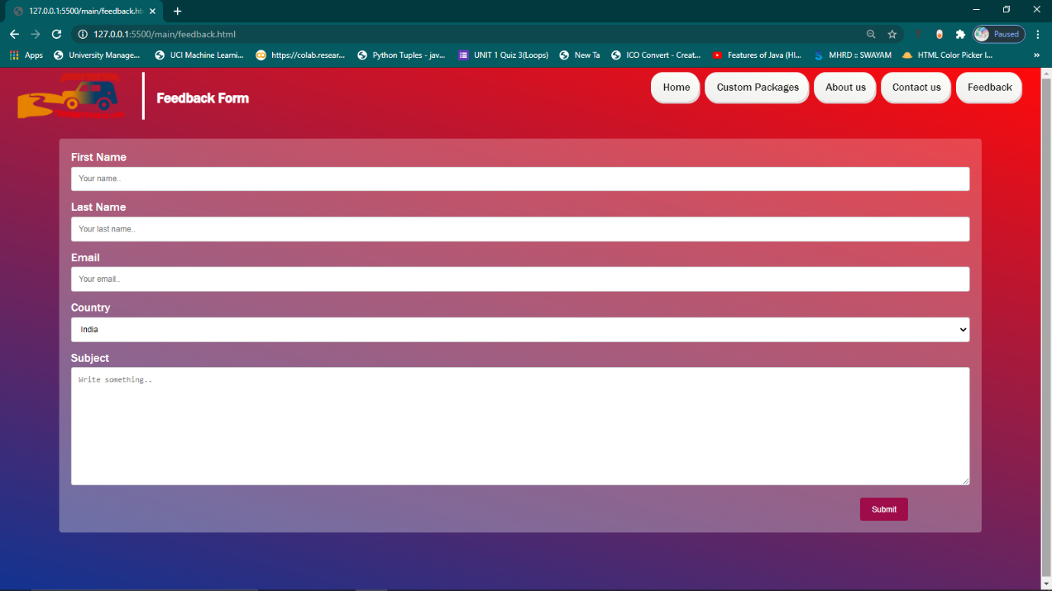

**Fig 4.1.4.1 Displaying Feedback form**

* HTML Code:

        <section>      //navbar

        <nav id="background2">  <img src="logo1.png"/>

            <div id = "container">

                <ul>

                    <a href="../main.html#background"><li>Home</li></a>

                    <li>Custom Packages

                        <ul>

                            <li>Adventure

                            <ul>

                                <a href="/Manali/Manali.html"><li>Manali</li></a>

                                <li>Goa beach</li>

                            </ul>

                            </li>

                            <li> Piligrams

                                <ul>

                                    <li>KedarDham</li>

                                    <li>Buddha</li>

                                </ul>

                            <li>Heritage

                                <ul>

                                    <li>Rajasthan</li>

                                    <li>Jabalpur</li>

                                </ul>

                            </li>

                        </ul>

                    </li>

                    <a href="../main.html#aboutus"><li>About us</li></a>

                    <a href="../main.html#contactus"><li>Contact us</li></a>

                   <a href="#"><li >Feedback</li></a>

                </ul>

            </div>

<h3 id="heading">Feedback Form</h3></nav> //heading

<div class="contained"> //form

  <form >

    <label for="fname">First Name</label>

    <input type="text" id="fname" name="firstname" placeholder="Your name.." required>

    <label for="lname">Last Name</label>

    <input type="text" id="lname" name="lastname" placeholder="Your last name.." required>

    <label for="Email"> Email</label>

    <input type="email" id="lname" name="Email" placeholder="Your email.." required>

    <label for="country">Country</label>

    <select id="country" name="country" required>

      <option value="australia">India</option>

      <option value="canada">Canada</option>

      <option value="usa">USA</option>

      <option value="usa">Australia</option>

    </select>

    <label for="subject">Subject</label>

    <textarea id="subject" name="subject" placeholder="Write something.." style="height:200px" required></textarea>

    <input type="submit" value="Submit">

  </form>

</div>

</section>

* **CSS Code:**

{

margin: 0;

padding: 0;

box-sizing: border-box;}

body {font-family:'Franklin Gothic Medium', 'Arial Narrow', Arial, sans-serif;

background:linear-gradient(15deg,rgba(9, 44, 141, 0.966) 0%,rgb(255, 10, 10)100%) ,transparent;

}

#background2{ //background

display: flex;

flex-direction: row;

margin-top: 0.4rem;

}

#container { //navbar

flex: 85%;

margin-left: 62%;

position: absolute;

}

#container ul{

list-style:none;

position: fixed;

}

#container ul li{

background:linear-gradient(15deg,rgb(240, 239, 238) 0%,rgb(253, 255, 250)100%) ,transparent;

padding-left: 20px;

padding-right:15px ;

margin-left: 10px;

border-radius: 20px;

box-shadow:   2px 3px gainsboro;

height: 50px;

line-height: 50px;

text-align: center;

float: left;

color:rgb(14, 13, 13);

font-size: 18px;

font-family: 'Franklin Gothic Medium', 'Arial Narrow', Arial, sans-serif;

font-style: bold;

position:relative;

}

#container ul li:hover {

background-image:url('buttonsbk1.jpg');

color: whitesmoke;

}

#container ul ul{

display:none;

}

#container ul ul li{

width:120px;

margin-left:-12px;

}

#container ul li:hover > ul{

display:block;

width:120px;

position: relative;;

}

#container ul ul ul{

margin-left:113px;

top:0px;

position: relative;

margin-top: -2.3rem;

}

#background2 img{

margin-top:-3rem;

margin-right: -4rem;

top:0;

margin-left: 1rem;

position: relative;

width: 200px;

z-index: 100;

}

#heading{ //heading

flex:9%;

margin-left: 5rem;

padding-left: 20px ;

border-left:5px solid rgb(255, 255, 255) ;

color: rgb(255, 255, 255);

font-family: 'Franklin Gothic Medium', 'Arial Narrow', Arial, sans-serif;

margin-bottom:3rem;

padding-top:1.5rem ;

}

input[type=text], input[type=email], select, textarea { //form input styling

width: 100%;

padding: 12px;

border: 1px solid #ccc;

border-radius: 4px;

box-sizing: border-box;

margin-top: 5px;

margin-bottom: 16px;

resize: vertical;

}

input[type=submit] {

background-color: #9e0d49;

color: white;

padding: 12px 20px;

border: none;

border-radius: 4px;

cursor: pointer;

margin-left: 100em;

}

input[type=submit]:hover {

background-color: #790808;

}

.contained{

border-radius: 5px;

background-color: #f2f2f2;

padding: 20px;

margin: 5rem;

margin-top: -1.4rem;

background:linear-gradient(15deg,rgba(240, 239, 238, 0.342) 0%,rgba(253, 255, 250, 0.233)100%) ,transparent;

color: white;

}

* **Javascript code:**

<script>

    function submitted(){

     return alert('Thank you for your feedback');

    }

</script>

**CHAPTER 5**

**VALIDATION CHECKS**

**5.1 Validation Checks**

We have applied validation check in sign up and login page under certain condition  **-**

**5.1.1 Sign Up/Login**

It is located in starting of website validated using javascript.

**5.1.1.1 Username-**

In this the form putting input in username is mandatory is validated through javascript

**5.1.1.2 Email ID**

In this putting email which contain “ xyz@example.com” is mandatory

**5.1.1.3 Password**

In this form password is mandatory by following certain rules they are mentioned below:

🡪There must be at least 8 characters

🡪 At least one must be any symbol like-“@,&”

🡪At least one must be any uppercase

🡪At least one must be any lowercase

🡪At least one must be any digit.

All above case are mandatory to mention in your password to get sign up/login .

**5.1.2 Feedback form**

It is located at navbar as button validated using html.

**5.1.2.1 Username-**

In this the form putting input in username is mandatory

**5.1.2.2 Email ID**

I n this putting email which contain “ xyz@example.com” is mandatory .

**CHAPTER 6**

**TESTING**

**6.1 Testing techniques**

In this whole website we have used testing teshniques in two inputs they are:

**6.1.1 Email-**

**Table 6.1.2.1 Test Scenario: LOGIN/signup**

|  |  |  |  |  |  |
| --- | --- | --- | --- | --- | --- |
| **Test case id** | **Test Case** | **Test Data** | **Expected Results** | **CONDITION** | **STATUS:-Pass**  **/ Fail** |
| **LP_1.** | Valid E-mail | tesT@example.com | Valid | Verified | PASS |
| **LP_2.** | Invalid E-mail | testjksdnjhudj | Invalid | Not-Verified | FAIL |

**6.1.2 Password-**

**Table 6.1.2.1 Test Scenario: LOGIN/signup**

|  |  |  |  |  |  |
| --- | --- | --- | --- | --- | --- |
| **Test case id** | **Test Case** | **Test Data** | **Expected Results** | **CONDITION** | **STATUS:-Pass**  **/ Fail** |
| **LP_1.** | Valid password | tesT@234 | Valid | Verified | PASS |
| **LP_2.** | Invalid password | test | Invalid | Not- Verified | FAIL |
| **LP_3.** | Invalid password | TEST | Invalid | Not- Verified | FAIL |
| **LP_4.** | Invalid password | Test | Invalid | Not- Verified | FAIL |
| **LP_5.** | Invalid password | Test123 | Invalid | Not-Matched | FAIL |

**CHAPTER 7**

**IMPLEMENTATION AND MAINTENANCE**

**7.1 Implementation**

We can implement serval platforms to it they are like -

🡪Transportation

🡪Festival Discount

🡪Seasonal package

🡪Weather forecast for tour planning

🡪Goodies with specific pack

**7.2 Maintenance**

* + - We can keep maintenance by updating new feature and replacing with older one. By activating firewall regularly.
    - And enhancing feature as per customer requirements.

**CHAPTER 8**

**FUTURE SCOPE OF THE PROJECT**

**8.1 Future scope of the project**

It have future scope in many different ways that are mentioned below:

🡪It will increase the tourism culture .

🡪Many people will get job offers according to requirements

🡪 It will be a way to connect India with different people of country.

🡪It will help in shaping our society economically .

🡪Encourage educational institute to provide tourism related course

**CHAPTER 9**

**GITHUB LINK AND VIDEO PRESENTATION LINK**

**9.1 GitHub link**

<https://drive.google.com/file/d/1rK_YB5fmOMiSY1E00MpT-SNNWHDybo55/view?usp=sharing>

**9.2 Video presentation link:**

<https://drive.google.com/file/d/1rK_YB5fmOMiSY1E00MpT-SNNWHDybo55/view?usp=sharing>

**REFERENCE:**

* <https://www.w3schools.com/html/>
* <https://www.thapatechnical.com/>
* <https://stackoverflow.com/>
* <https://fontawesome.com/download>
* <https://www.youtube.com/>